Test Codes:

1. Read memory

#pragma align 4;

N = 1;

bl = 1;

uint64_t sum = 0;

uint32_t mat[65536];

for (uint32_t i = 0; i < 65536; i++)

{

sum += mat[i];

RM(&mat[i], sizeof(uint32_t));

}

Output:

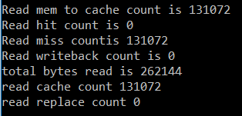

1. Read Memory

#pragma align 4;

N = 1;

bl = 2;

uint64_t sum = 0;

uint32_t mat[65536];

for (uint32_t i = 0; i < 65536; i++)

{

sum += mat[i];

RM(&mat[i], sizeof(uint32_t));

}

Output:

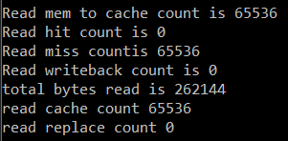

1. Write Memory

#pragma align 4;

WS = 1;

N = 1;

bl = 1;

uint8_t mat[262144];

for (uint32_t i = 0; i < 262144; i++)

{

mat[i] = 0;

WM(&mat[i], sizeof(uint8_t));

}

Output

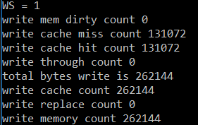

1. Write Memory

#pragma align 4;

WS = 1;

N = 1;

bl = 2;

uint8_t mat[262144];

for (uint32_t i = 0; i < 262144; i++)

{

mat[i] = 0;

WM(&mat[i], sizeof(uint8_t));

}

Output:

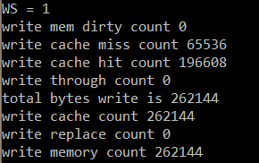

1. Write Memory

#pragma align 16;

WS = 1;

N = 1;

bl = 1;

uint8_t mat[524288];

for (uint32_t i = 0; i < 524288; i++)

{

mat[i] = 0;

WM(&mat[i], sizeof(uint8_t));

}

Output:

